COMP 111 - Week 1 Learning Activities

Activity 1-1
Outcome: Use an Integrated Development Environment (IDE) to edit, compile, and run a Java program.

Once BlueJ has been installed on your computer, start the development environment either from the desktop shortcut or the start menu. From the Project menu select “Open Project” and browse to the COMP111/Activities/Week01 folder on your computer. Select and open the project named “IntroToBlueJ.” Your screen should look something like the following figure:

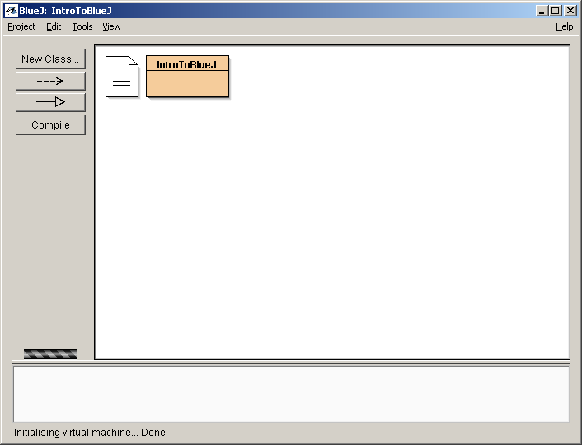

You should see two boxes there, one that looks like a text document and another larger box labeled “IntroToBlueJ.” Double click on the text document. What kind of information is there?

_________________________________________________________________

To run this application, simply right-click on the box labeled “IntroToBlueJ” as shown. A small list of choices should appear to the right of the mouse. Of these, select the one that reads “void main(String[] args).” Whenever you wish to run a program in Java, you will always choose this option.

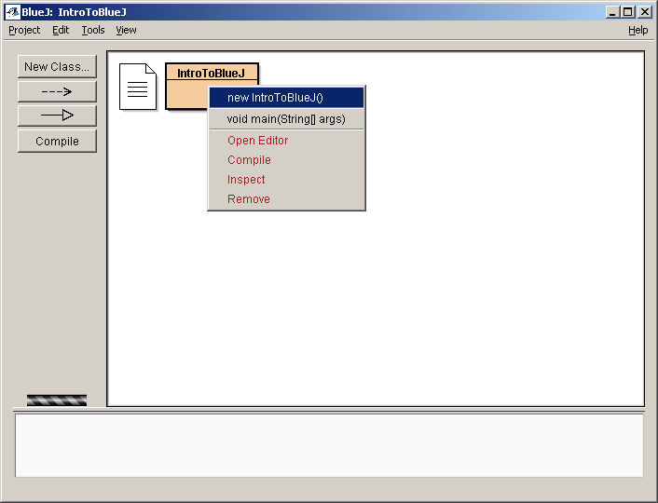

A dialog will then appear asking you what arguments you would like to start the program with. For now, you can just ignore this question and go on. Once that is done, the program will execute and a new window will appear. This is the console output window, displaying the outcome of running the program.

What does it say in the window?

_ _____________________________________________

Close the console output window and run the program again exactly as you did before, by executing main.

What happened? Why do you think the program behaved like that?

Close the output window again and look at your project screen. This time double click on the “IntroToBlueJ” box. This time it opens an editor, showing you the content of the file. This is what a very simple Java program looks like.

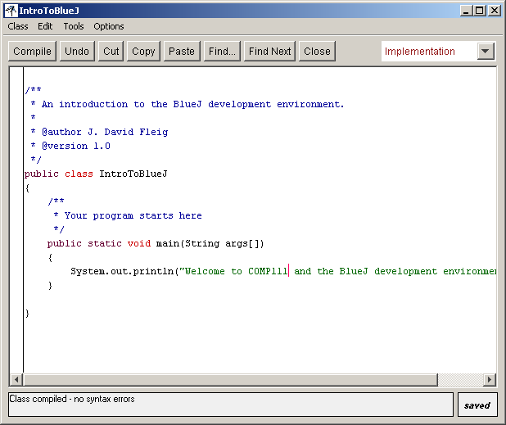

Examine the line that starts with System.out.println. What do you think this command does?

Change the text inside the quotes by adding “Hello <your name>” to the front, replacing <your name> with your own name. On the toolbar there is a button labeled “Compile;” click this now. Whenever you make changes to a file you will need to compile that file again in order for your changes to work. At the bottom of the window it should say, “Class compiled – no syntax errors.” Close this window and try running your program again. What does it say now?

Activity 1-2
Outcome: Employ the feedback from an automatic grading system to correct program deficiencies.

Using the project from Activity 1-1, modify the program so that it displays a brief description of you. This description should include information like your name, why you are taking the course, and some fact others should know about you. Be sure your program runs like the sample did, displaying the information you specified to the screen, and then follow the instructions provided by your professor as to how you should submit your assignment electronically. This submission information will be important for handing in assignments throughout the course.

Note: You may wish to refer to Appendix A (“How do I Submit an Assignment for Automatic Grading: And Why am I Losing Points?”), found on the COMP 111 Student Resource CD and also linked in the Weekly Preparation section for Week 2.

Activity 1-3
Outcome: Distinguish between and correct syntax and logic errors.

Working within BlueJ, open the project named “Errors,” found under the COMP111/Activities/Week01 directory. Double-click on the box labeled “CorrectProgram.” What do you expect this program to do when it is run?

Run the program and make sure the program meets your expectations. Now, go back to the editor and remove the semicolon from the end of the first System.out.println statement. Recompile the program. What message do you see? What happened?

Notice that you did not receive the message, “Class compiled – no syntax errors.” If there is a mistake in your code such that it will not compile, you have what is called a syntax error. Usually syntax errors are due to typographical errors, misspelled words, and other such oversights. Click on the button with the question mark toward the lower right corner of the project window. Doing so may give you more information about the particular error.

Now replace the semicolon and recompile the program to make sure the error goes away. Try removing the last double quotation from the same line and compile again. What message do you get now?

Text enclosed within quotes is shown in green by default. Notice that the text color changed when you removed the quotation mark even without recompiling.

Take a look at your project window again. You will see that the box labeled “CorrectProgram” has a small icon in the lower left corner. This indicates that there are problems in the code, and the program will not compile. Try to run the program. What do you notice?

Go back and insert the missing quotation mark. Make sure the program compiles fine again before moving on. Now, make a change in the second line so that the second 6, is now a 7. Compile the program. What happened? Why?

Run the program. Is the program correct? (In other words, did it do what it is supposed to do by design/purpose?)

The program now has what is known as a logic error. Logic errors cannot be caught by the compiler and are left for humans and test cases to find. Syntax errors are usually easy to find and easy to fix; logic errors tend to be much harder in both cases.

You will frequently encounter both types of errors as you write programs. As extra practice go ahead and close “CorrectProgram”; then double-click on the box marked “BuggyProgram.” Identify and correct all syntax and logic errors for each line, listing them below:

Line 1 : _________________________________________________________________

Line 2: _________________________________________________________________

Line 3: _________________________________________________________________

Line 4: _________________________________________________________________
Activity 1-4
Outcome: Describe the inputs, activities, and outputs for each step in the compilation process.

Write a program that prints a staircase as in the diagram below:

+---+
| |
+---+---+
| | |
+---+---+---+
| | | |
+---+---+---+---+
| | | | |
+---+---+---+---+

Describe below everything you have to do to write your program and get it to execute.

