COMP 111 - Week 3 Learning Activities

Activity 3-1
Outcome: Instantiate and use an object from a class.

Start the BlueJ development environment either from the desktop shortcut or the start menu. On your computer, create a directory in which to keep all your development projects for this course. From the BlueJ Project menu, select “New Project” and give this project a name, such as UsingObjects. This will be your project for this activity. Because you will need to type Java statements, make sure “Show Code Pad” is checked under the View menu bar option. The code pad appears in the bottom right portion of the program window. In this area, you can type Java code that will be executed each time you press Enter.

For example, type the following and press Enter:

System.out.println(“Test”);

It may take a few moments, but the console output window should open with the results of this code. The delay is due to the Java Virtual Machine loading up for the first time.

Try typing in some of the example code you read earlier in the textbook:

int luckyNumber = 13;

Notice that the cursor just goes to the next line without displaying any result. This is because you simply declared a variable but did not type code that would display a result. Now try typing the following:

System.out.println(luckyNumber);

The code pad is not meant to be used for writing a full program, but it is available to let you play with the code and try out things. If you wish to use the code pad to test some code that requires more than a single line, just use Enter between the lines. For example, type:

int luckyNumber = 13; <Enter>
System.out.println(luckyNumber); <Enter>

This sequence should run as you would expect, displaying the number 13 in the output window. Note that you can use the up-arrow and down-arrow keys to look through your input history.

Working with objects is a little more flexible. Try creating a String object by typing:

new String(“I do not want”)

Take notice that there is no semicolon at the end of this line. When you press Enter, the next line should say: “I do not want” (String)

The left part of the display tells you the value of the object if it can be displayed, while the portion on the right within parentheses identifies the type of the object. In this case, you have a String object whose value is “I do not want.” You should also see a small red icon; this icon identifies that an object was just created. You have the option of dragging this red icon to the left and dropping it in the currently empty window. Go ahead and do this now.

At this point, you should be given the option of naming your new String object. Call it firstPart for now, as you will be making more of these objects. Congratulations you have just instantiated your first object! The result of the process you just completed is the same as what would have resulted from the following code:

String firstPart = “I do not want”;

or

String firstPart = new String(“I do not want”);

Objects do not go away between lines, so going back to the code pad you can write:

System.out.println(firstPart);

At this point, the phrase should appear in the output console window. Now try to do the following:

- Create a String called middlePart whose value is “ to be killed because of a typo”
- Create a String called lastPart whose value is “ – that would be embarrassing.”
- Combine the three strings into a single string, msg, by typing the following: new String(firstPart + middlePart + lastPart)
- Print your message to the console output.
- Print the length of the string to the console output.

Activity 3-2
Outcome: Examine how accessor and mutator methods affect objects.

You have already read in your textbook a description of a Rectangle object that contains a position (x,y) along with its dimensions of width and height. Imagine a slightly simpler concept, that of just a point. With a point you do not need to worry about the dimensions and can just focus on the point’s position on a grid.

Open the project named “AccessorAndMutatorMethods” under the COMP111/Activities/Week03 directory. Your screen should look something like the following figure:

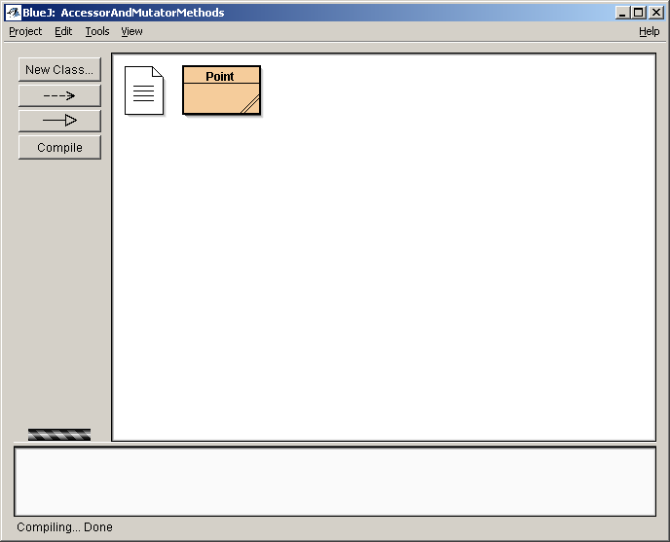

The Point class contains two pieces of information, its x- and y-coordinates. There are two accessor methods:

public int getX()
public int getY()

two mutator methods:

public void shiftX(int x)
public void shiftY(int y)

and two constructors which you can use as follows:

new Point()
new Point(5,10)

You will now create a new Point object in two different ways. First, using the code pad, do the following, showing your code on the given line:

Create a new Point object, called point1, using the default constructor.

Create a new Point object, called point2, whose position is (2,7).

Display the x-coordinate of point2 to the default console.

Use the shiftY method to set the y-coordinate of point1 to 9.

You can also create objects graphically using BlueJ. Right-click on the class Point above. You will see a pull-down menu of a few options, such as opening the editor and compiling. At the very top of the menu, you will see the two different constructors. Try making a Point object to represent a point at (1,1). Right-click on new Point(int x,int y).

A new window should appear giving you the option of inserting the values manually for any parameters. Create the point and call it point3. Notice that a picture for point3 has appeared in the lower left with the previous two objects.

Try to do the following using the code pad with your objects, showing your code on the lines:

Display the x-value of point1.

Set the y-value of point2 to one more than the x-value of point3.
Hint: In order to do the necessary calculation, it would be useful to first set the y-value of point2 back to 0 since you don't know what value it currently holds. To set the y-value of point2 back to zero, you can do this: point2.shiftY( - point2.getY( )).

Set the x-value of point3 to twice the sum of the x-values of point1 and point2.
Hint: You can use a modification of the hint above to do this calculation.

Display the x-and y-coordinates of point2.

Display the x-and y-coordinates of point3.

You can also accomplish the above tasks graphically by right-clicking on an object. Try that now on point3. You should see the four different methods you have been using. Experiment with this option and try to set the y-value of point1 equal to the x-value of point3.

What is the new location of point1?

Activity 3-3
Outcome: Create and execute unit tests for pre-written objects.

Open the project named “Testing” Under the COMP111/Activities/Week03 directory. Your screen should look something like the following figure:

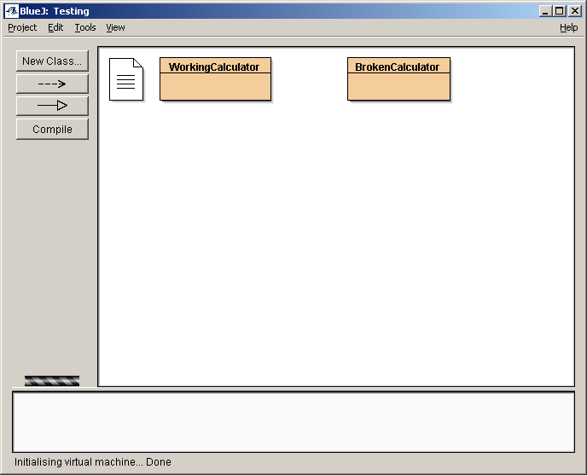

The WorkingCalculator class simulates a very basic calculator and has eight public methods:

public void enter(double val)
public void add()
public void subtract()
public void multiply()
public void divide()
public void clear()
public double equals()

These eight methods behave like a normal calculator would behave. The clear() method clears the calculator of all values. The enter() method allows the user to enter a number into the calculator. The add(), subtract(), multiply(), and divide() methods all function as you would expect. An example of how one might use the calculator is shown below:

Testing is an integral part of software development. You can make test cases that check whether or not these methods do what they should. Right-click in an empty portion of the main window and select “New Class.” Make sure the type is “Unit Test” and give this class the name WorkingCalculatorTest. Your screen should now look like the following:

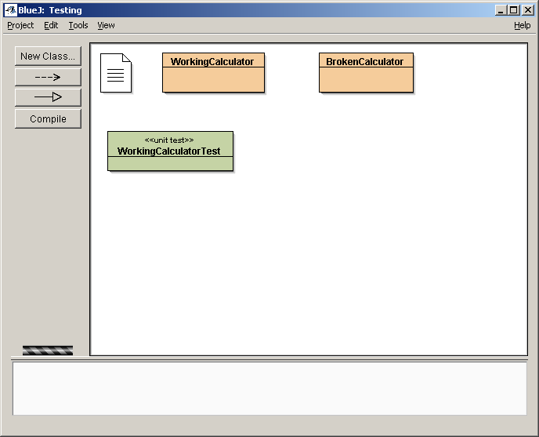

Double-click on your new unit test class to get to the editor. You will see a skeleton already implemented for you, and all you need to do is fill in the test cases. For now you can ignore what is already in the file. However, before you can do anything, you have to decide the type of test you wish to run. You can check whether the add method works properly by using a simple calculation of 3.0 + 4.0 = 7.0.

One way to test the WorkingCalculator add method would be to create a WorkingCalculator object and try it out with code such as the following:

WorkingCalculator calc = new WorkingCalculator();
calc.clear();
calc.enter(3.0);
calc.add();
calc.enter(4.0);
double answer = calc.equals();
System.out.println(answer);

If 7.0 appeared in the output, then you could say the program works for adding 3.0 and 4.0. However, you don’t want to have to check the screen every time you run a test. When you build a unit test, there are a few additional commands that you can use such as the following:

assertEquals(double expected, double actual, double delta)
assertEquals(int expected, int actual)
assertEquals(String expected, String actual)

Each of these available methods checks to see if the value you get as a result (actual) is the same as what you were expecting. Notice that for comparing double values there is a third parameter, delta. This parameter is included to account for possible rounding errors associated with using floating-point numbers. If you wish to compare double values, you should specify a certain tolerance of how close the two numbers should be in order for you to consider them to be equal.

The code listed below can be used as the first test case inside WorkingCalculatorTest:

/**
* Test case to check if adding two numbers works correctly
*/
public void testAdd()
{
WorkingCalculator calc = new WorkingCalculator();
calc.clear();
calc.enter(3.0);
calc.add();
calc.enter(4.0);
double answer = calc.equals();
assertEquals(7.0, answer, .01 );
}

Once you compile and save this code, notice the change on your project screen. WorkingCalculatorTest now has a dashed line to WorkingCalculator.

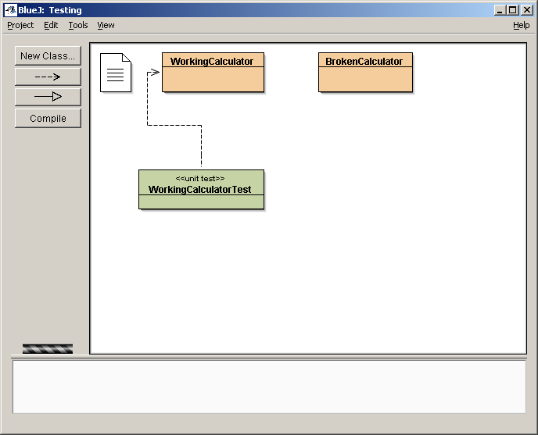

Now, check to see what happens when you run the test. Right-click on WorkingCalculatorTest, and choose “TestAll.” You have the option to run the test case by itself as well, but normally you will want to run all the tests. Once you do this, a new window should display indicating the results of your test cases.

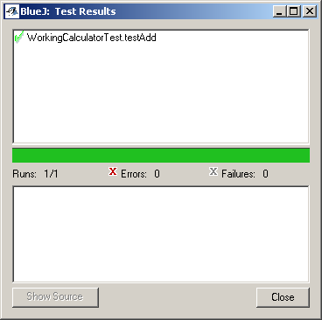

As expected, the test case passed. What if you had expected the answer to be 6.0 instead of 7.0? Try running a test with that condition. What do you find?

Use the following page to write down in English a list of test cases for the WorkingCalculator methods. Then write how you would implement the tests for each method.

You should have, at the very minimum, four tests by now, one for each different method in WorkingCalculator. However, most likely you should have more than that. Did you try adding 0 to a number? Subtracting 3 from 4 and 4 from 3? Multiplying by 1? Multiplying by 0? Dividing by 1? What do you expect to happen in each of these situations? (Do not worry about checking the situation where you divide by zero just yet. That is a situation where you would expect the method to fail, and that situation will be discussed later.)

Each separate test you add should do only enough work to check that test case. If you were to write one long test case that tries to do everything and something blows up on the first check, then the rest would not be run.

Once you think you have created all your test cases for the calculator, try to use your tests on BrokenCalculator. This class is basically identical to WorkingCalculator except that there are mistakes in the code. Don’t cheat and try and find the bugs by looking at the source code yet. This activity is intended to give you practice developing and running test cases. Visually finding the bugs in this code may be simple, but later on in more complex code when you can’t just visually spot bugs so easily, the better route to find them is by using test cases.

Either change your current tests to test BrokenCalculator or make a new set. Run your tests and identify which test cases fail:

As you see, you do not have to know how something works to be able to accurately execute tests. Furthermore, you can design the tests purely by knowing how the system should behave ahead of time. This is an important concept! If you have a design of what the system should do, you can even make your test plan before you write any code.

Activity 3-4
Outcome: Use API documentation to explore object interfaces.

The Java API (Application Programming Interface) documentation lists the classes and methods of the Java library.
Go to http://java.sun.com/j2se/1.5/docs/api/index.html and read about what the StringTokenizer class does. Summarize in your own words.

Read about the countTokens and nextToken methods of the StringTokenizer class. Summarize in your own words.

What does the following code snippet do:

String sentence = "Mary had a little lamb.";
StringTokenizer mystery = new StringTokenizer(sentence);
System.out.println(mystery.countTokens());
System.out.println(mystery.nextToken());
System.out.println(mystery.nextToken());

Activity 3-5
Outcome: Explain the difference between a reference and the object it references.

The following two example sets of code create and manipulate variables and objects in memory.

Example 1:

Line 1: int x = 5;
Line 2: int y = 2;
Line 3: x = y + 1;
5
1. x

5
2
2. x y

3. x y
3
2

Example 2:

Line 1: Point myPoint = new Point(2,4);
Line 2: Point myPoint2 = new Point(1,2);
Line 3: myPoint = myPoint2;
Line 4: myPoint2.setX(0);
Point

x = 2, y = 4
1. myPoint

2. myPoint
Point

x = 1, y = 2

myPoint2
Point

x = 2, y = 4

3. myPoint
Point

x = 1, y = 2

myPoint2
Point

x = 2, y = 4

4. myPoint

Point

x = 0, y = 2

myPoint2
Point

x = 2, y = 4

In a way similar to that illustrated in the previous two examples, for each of the following problems, illustrate what happens in each step with a series of diagrams.

Problem 1:
Line 1: int x=10;
Line 2: int y=5;
Line 3: int z=x;
Line 4: z = y;

Problem 2:
Line 1: int x=2;
Line 2: int y=4;
Line 3: Point myPoint = new Point(x,y);
Line 4: x = 1;

Problem 3:
Line 1: Point myPoint = new Point();
Line 2: myPoint.setX(5);
Line 3: Point myPoint2 = myPoint;
Line 4: myPoint2.setY(6);
Line 5: myPoint2 = new Point();

Problem 4:
Line 1: Point myPoint = new Point(1,9);
Line 2: int x = myPoint.getX();
Line 3: int y = myPoint.getY();
Line 4: myPoint.setX(0);

